|  |  |  |
| --- | --- | --- |
| **Ultrasonic sensor** |  | **UBS4000-30GM-IUO-V15** |
| **Technical data** |  | |  | | --- | |  | | |
| General Specifications |  |
| Sensing distance | 200…4000mm |
| Adjustment range | 200…4000mm |
| Unusable area | 0…200mm |
| Standard target plate | 300mm×300mm |
| Transducer frequency About | 75 kHz |
| Response delay About | 125ms |
| **Indicators/Operating means** |  |
| LED Blue |  |
| Electrical specifications |  | |  | | --- | |  | | |
| **Operating voltage U**B | 10…30VDC ripple10%ss |
| No-load supply current | ≤30mA |
| **Output** |  |
| Output type | 0 --- 10V & 4 -- 20mA/ |
| **Resolution** |  |
| Deviation of the characteristic  curve | ±1% of full-scale value |
| Repeat accuracy | ±0.1% of full-scale value |
| Load impedance | ≤500 Ohm |
| **Maximum switching current** |  |
| Temperature influence | ±1.5% of full-scale value |
| **Ambient conditions** |  |
| Ambient temperature | -25…70℃ |
| Storage temperature | -40…85℃ |
| **Mechanical specifications** |  | |  | | --- | |  | | |
| **Protection grade** | IP67 |
| Connection | Connector M12,5-PIN |
| **Material** |  |
| Housing | Brass nickel-plated |
| **Transducer** | epoxy resin/hollow glass sphere  mixture; Polyurethane foam | **1 BROWN：+U 2 WHITE: 0 -- 10V  3 BLUE: -U 4 BLACK: 4—20mA**  **5 GREY: SYNC** |
| **Weight** | 280g |
| **Compliance with standards and Directives** | |
| Standard conformity | EN 60947-5-2:2020 |  |

**Synchronization**

This sensor features a synchronization input for suppressing ultrasonic mutual interference ("cross talk").If the input port is not switched on, the sensor operates at the internal frequency. A square wave voltage can also be added to the input port to synchronize the sensor. A synchronization pulse on the synchronization input initiates a measurement cycle. The synchronization pulse width must be greater than 100ms. The measurement period is triggered by the falling edge of the pulse. Because the sensor uses the average of five measurements internally, the switching state changes only when all five measurements exceed the switching threshold. If the low level duration reaches or exceeds 1 second, or if the synchronous input port is suspended, the sensor will operate normally. Synchronization is not allowed during the setting period. Otherwise, learning cannot be performed if synchronization is used. Synchronization can work in two ways.

1. Multiple sensors are triggered by the same synchronization signal and work synchronously.

2. The synchronization pulse is output to a sensor in turn, that is, each sensor works in multiple ways. Adding a high level tothe synchronous input stops the sensor.

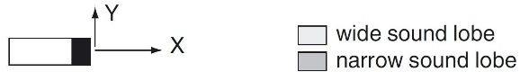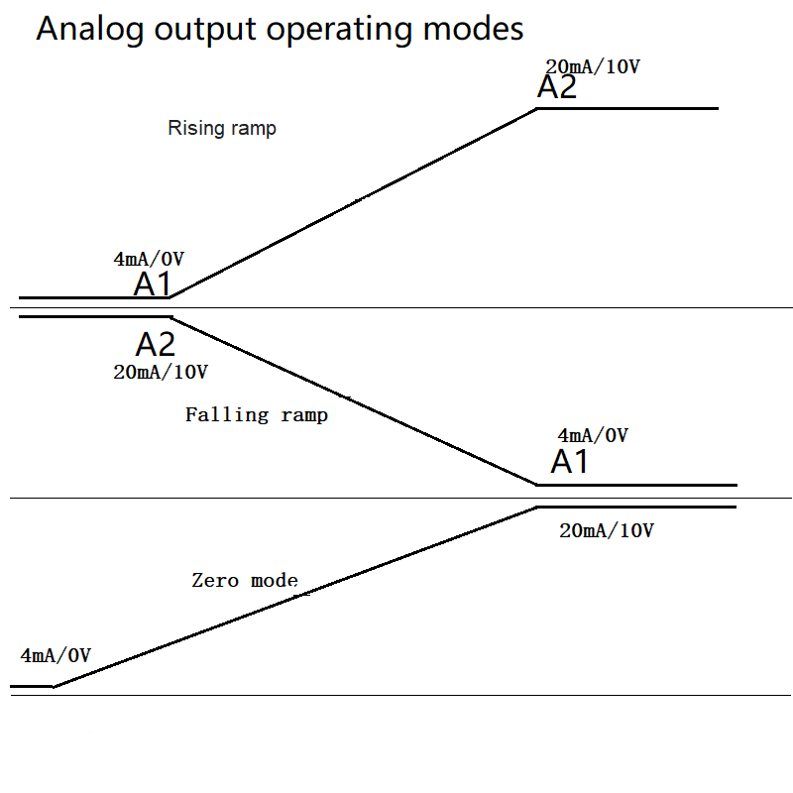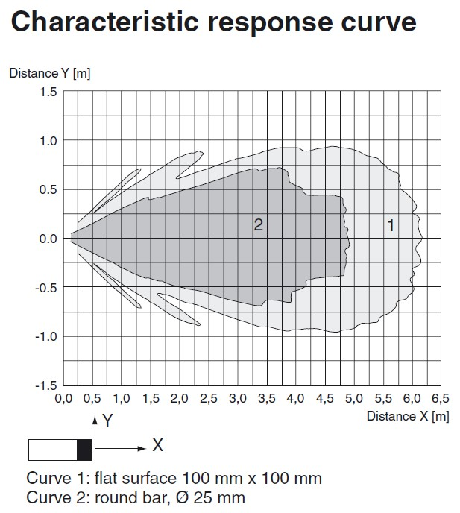

|  |
| --- |
| **Adjusting the evaluation limits**  The ultrasonic sensor features an analogue output with two teachable evaluation limits. These are set by applying the supply  voltage -UB or +UB to the TEACH-IN input. The supply voltage must be applied to the TEACH-IN input for at least 1 s.  . The lower evaluation limit A1 is taught  with -UB, A2 with +UB.  Two different output functions can be set:  1. Analogue value increases with rising distance to object (rising ramp)  2. Analogue value falls with rising distance to object (falling ramp)  Evaluation limits may only be specified within the first 5 minutes after  Power on. To modify the evaluation limits later,  the user may specify the desired values only after a new Power On.  **TEACH-IN rising ramp (A2 > A1)**  - Position object at lower evaluation limit  - TEACH-IN lower limit A1 with - UB  - Position object at upper evaluation limit  - TEACH-IN upper limit A2 with + UB  **TEACH-IN falling ramp (A1 > A2):**  - Position object at lower evaluation limit  - TEACH-IN lower limit A2 with + UB  - Position object at upper evaluation limit  - TEACH-IN upper limit A1 with - UB    Default setting  A1: unusable area  A2: nominal sensing range  Mode of operation: rising ramp |

